Time Series: 5th lesson – Hybrid Models

Linear regression excels at extrapolating trends, but can't learn interactions. XGBoost excels at learning interactions, but can't extrapolate trends. In this lesson, we'll learn how to create "hybrid" forecasters that combine complementary learning algorithms and let the strengths of one make up for the weakness of the other.

Components and residuals:

So that we can design effective hybrids, we need a better understanding of how time series are constructed. We've studied up to now three patterns of dependence: trend, seasons, and cycles. Many time series can be closely described by an additive model of just these three components plus some essentially unpredictable, entirely random *error*:

series = trend + seasons + cycles + error

Each of the terms in this model we would then call a component of the time series.

The residuals of a model are the difference between the target the model was trained on and the predictions the model makes -- the difference between the actual curve and the fitted curve, in other words. Plot the residuals against a feature, and you get the "left over" part of the target, or what the model failed to learn about the target from that feature.

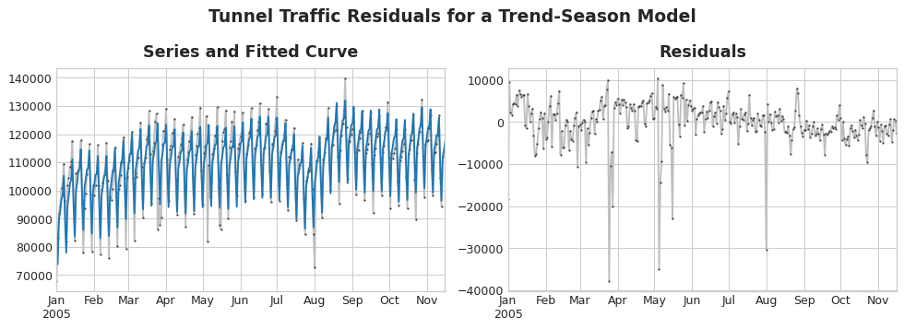

On the left of the figure above is a portion of the *Tunnel Traffic* series and the trend-seasonal curve from Lesson 3. Subtracting out the fitted curve leaves the residuals, on the right. The residuals contain everything from *Tunnel Traffic* the trend-seasonal model didn't learn.

We could imagine learning the components of a time series as an iterative process: first learn the trend and subtract it out from the series, then learn the seasonality from the detrended residuals and subtract the seasons out, then learn the cycles and subtract the cycles out, and finally only the unpredictable error remains.

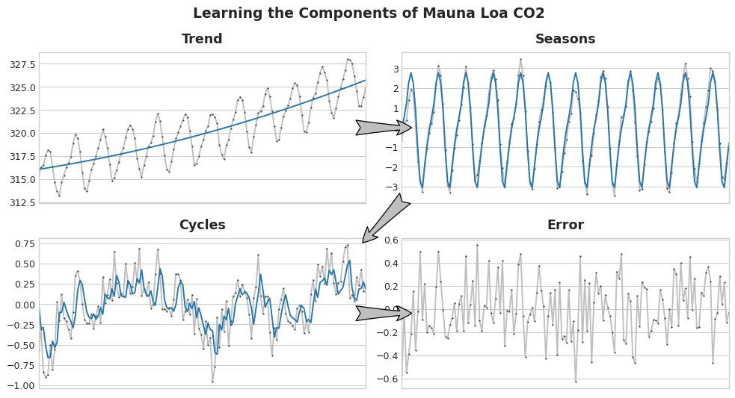

Add together all the components we learned and we get the complete model. This is essentially what linear regression would do if you trained it on a complete set of features modeling trend, seasons, and cycles.

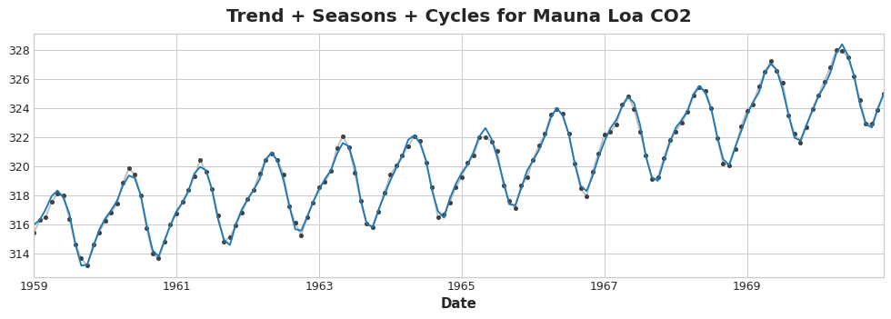

Hybrid forecasting with residuals:

In previous lessons, we used a single algorithm (linear regression) to learn all the components at once. But it's also possible to use one algorithm for some of the components and another algorithm for the rest. This way we can always choose the best algorithm for each component. To do this, we use one algorithm to fit the original series and then the second algorithm to fit the residual series.

In detail, the process is this:

# 1. Train and predict with first model

model_1.fit(X_train_1, y_train)

y_pred_1 = model_1.predict(X_train)

# 2. Train and predict with second model on residuals

model_2.fit(X_train_2, y_train - y_pred_1)

y_pred_2 = model_2.predict(X_train_2)

# 3. Add to get overall predictions

y_pred = y_pred_1 + y_pred_2

We'll usually want to use different feature sets (X_train_1 and X_train_2 above) depending on what we want each model to learn. If we use the first model to learn the trend, we generally wouldn't need a trend feature for the second model, for example.

While it's possible to use more than two models, in practice it doesn't seem to be especially helpful. In fact, the most common strategy for constructing hybrids is the one we've just described: a simple (usually linear) learning algorithm followed by a complex, non-linear learner like GBDTs or a deep neural net, the simple model typically designed as a "helper" for the powerful algorithm that follows.

Designing hybrids:

There are many ways you could combine machine learning models besides the way we've outlined in this lesson. Successfully combining models, though, requires that we dig a bit deeper into how these algorithms operate. There are generally two ways a regression algorithm can make predictions: either by transforming the features or by transforming the target. Feature-transforming algorithms learn some mathematical function that takes features as an input and then combines and transforms them to produce an output that matches the target values in the training set. Linear regression and neural nets are of this kind.

Target-transforming algorithms use the features to group the target values in the training set and make predictions by averaging values in a group; a set of feature just indicates which group to average. Decision trees and nearest neighbors are of this kind. The important thing is this: feature transformers generally can extrapolate target values beyond the training set given appropriate features as inputs, but the predictions of target transformers will always be bound within the range of the training set. If the time dummy continues counting time steps, linear regression continues drawing the trend line. Given the same time dummy, a decision tree will predict the trend indicated by the last step of the training data into the future forever. Decision trees cannot extrapolate trends. Random forests and gradient boosted decision trees (like XGBoost) are ensembles of decision trees, so they also cannot extrapolate trends.

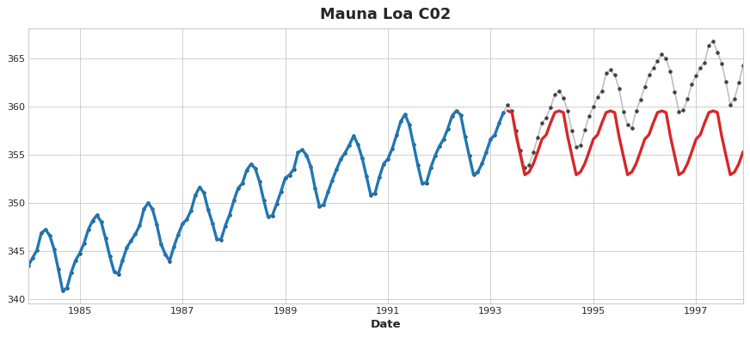

This difference is what motivates the hybrid design in this lesson: use linear regression to extrapolate the trend, transform the target to remove the trend, and apply XGBoost to the detrended residuals. To hybridize a neural net (a feature transformer), you could instead include the predictions of another model as a feature, which the neural net would then include as part of its own predictions. The method of fitting to residuals is actually the same method the gradient boosting algorithm uses, so we will call these boosted hybrids; the method of using predictions as features is known as "stacking", so we will call these stacked hybrids.